**Elements of Visualization Design**

Activity Guide

With your group, discuss problems with the following charts and ways to better design them to tell a story. List problems and potential solutions or create a new chart on a whiteboard that demonstrates better design principles.

See these online at the following link: <https://public.tableau.com/profile/al.blaine#!/vizhome/BadExamples/AudienceScorevsWorldwideGross>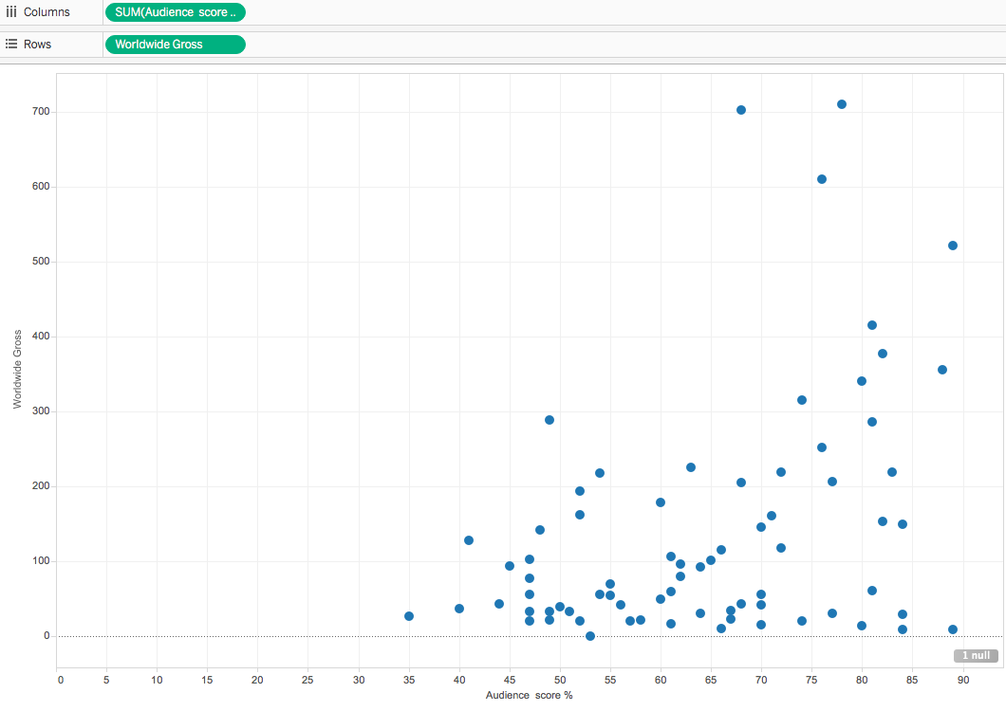

**Example 1: Scatterplot**  
This graph shows audience score (X-axis) and Worldwide Gross revenue in millions of dollars (Y-axis). The purpose of this graph is to see if there is a correlation between box office gross revenue and a film’s audience score. What would help make this visualization better?

**Example 2: Pie Chart**

This pie chart attempts to show how much film studios compare in terms of gross revenue.

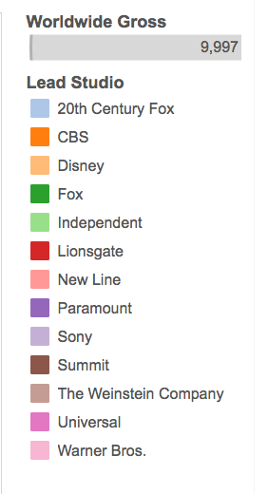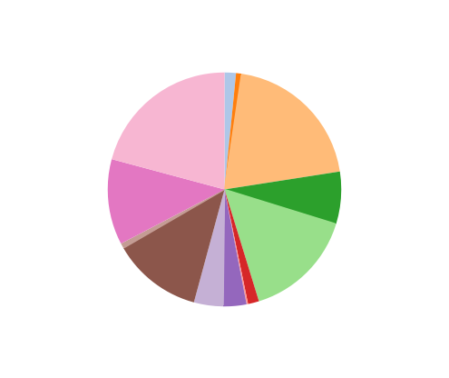

**Example 3: Bar chart**

This bar chart shows worldwide gross by film and genre. Each color stripe is one film. It’s too busy and needs help!

